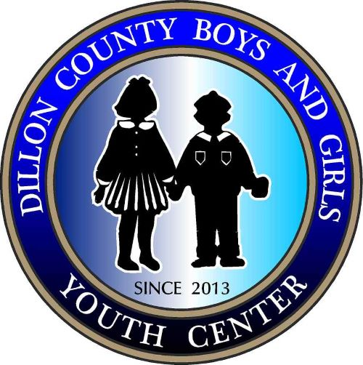

_____________________________________(hereafter “Business Expo Committee”) and
_____________________________________(hereafter "Vendor”) hereby agree to the following.

The vendor shall provide their own tables, chairs, decorations, electricity and equipment necessary to run their operation.
The vendor shall set up @ The lot in front of Gordon Elementary. Set up beginning @ 8:00 am. This event is from 10-5 pm.
The vendor shall abide by the following guidelines. The vendor takes responsibility for any damages or incidents that occur at his;/her booth.
- No Alcohol Allowed on site.
- No pets/animals allowed.
- Performs cleanup of your area, to include removal of all trash.
The vendor shall provide their own help/assistants.
The Dillon County Boys and Girls Youth Center is permitted to take photographs of the vendors and booths/tables for advertisement or use in social media advertising.

In witness to their agreement to the terms of this contract, the parties affix their signatures below.

____________________________________ ________________________________
Small Business Committee, Signature & Date Vendor Signature & Date

Please submit applications and $ fee NLT 1 June 2023.
Please email application to: dcbgycexpo@gmail.com

POC: Annie Smith 843-758-1192 POC: Danielle M. Smith 843-676-5818

